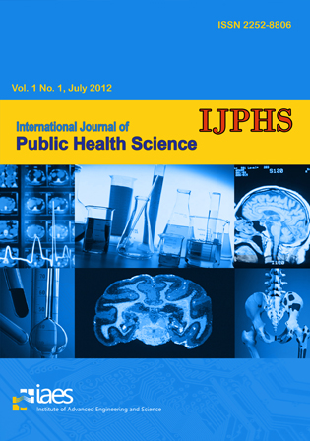

EDITORIAL TEAM

Advisory Board
- Prof. Hans-Olov Adami, Harvard School of Public Health, United States
- Assoc. Prof. Dr. Luoping Zhang, University of California, Berkeley, United States
- Dr. Khalid M. Al Aboud, King Faisal Specialist Hospital and Research Centre, Saudi Arabia

Editor-in-Chief
- Prof. Dr. Jay G. Silverman, University of California, San Diego School of Medicine, United States

Managing Editor
- Dr. Lina Handayani, Universitas Ahmad Dahlan, Indonesia

Associate Editors
- Assoc. Prof. Dr. Rob Martinus Van Dam, National University of Singapore, Singapore
- Assoc. Prof. Dr. Mohd Hasni Jaafar, Universiti Kebangsaan Malaysia, Malaysia
- Assoc. Prof. Dr. Henry Odhianosen Imhonde, Ambrose Alli University, Nigeria
- Prof. Dr. Mane Abhay Babruwahan, Smt. Kashibai Navale Medical College, India
- Dr. Ellina Lytvyak, University of Alberta, Canada
- Dr. Fazal Shirazi, MD Anderson Cancer Center, United States
- Dr. Miguel A. Mayer MD, PhD, MPH, MSc, Dipl, Universitat Pompeu Fabra, Spain
- Dr. Muhiuddin Haider, University of Maryland, United States
- Dr. Tassanee Rawiworrakul, Mahidol University, Thailand
- Dr. Xiaoli Gao, University of Texas Health Science Center at San Antonio, United States
- Dr. Yuming Guo, Monash University, Australia

International Journal of Public Health Science (IJPHS)
p-ISSN: 2252-8806, e-ISSN: 2620-4126

